**Quiz**

Top of Form

**Question 1 (1 point)**

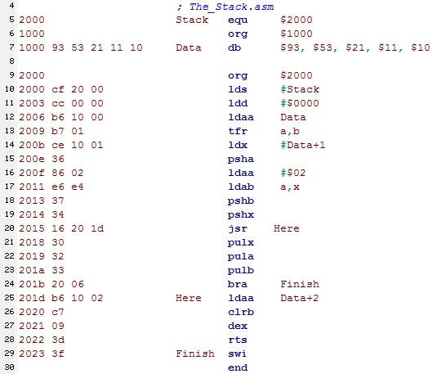  
After the execution of line 10, SP contains what value?

Question 1 options:

|  |  |
| --- | --- |
|  | $1003 |
|  | $2000 |
|  | $1000 |
|  | $9353 |

**Question 2 (1 point)**

After the execution of line 12, B contains what value?

Question 2 options:

|  |  |
| --- | --- |
|  | $9353 |
|  | $53 |
|  | $93 |
|  | $00 |

**Question 3 (1 point)**

After the execution of line 13, A contains what value?

Question 3 options:

|  |  |
| --- | --- |
|  | $21 |
|  | $53 |
|  | $93 |
|  | $00 |

**Question 4 (1 point)**

After the value of A is pushed onto the Stack in line 15, SP contains what value?

Question 4 options:

|  |  |
| --- | --- |
|  | $FFFF |
|  | $0000 |
|  | $2000 |
|  | $1FFF |

**Question 5 (1 point)**

After the execution of line 17, B contains what value?

Question 5 options:

|  |  |
| --- | --- |
|  | $21 |
|  | $10 |
|  | Unknown as X points past the Data array |
|  | $11 |

**Question 6 (1 point)**

After the execution of line 20, what is the contents of memory addresses $1FFA and 1FFB?

Question 6 options:

|  |  |
| --- | --- |
|  | $1FFA |
|  | $2018 |
|  | $2017 |
|  | $201C |

**Question 7 (1 point)**

After the execution of line 27, X contains what value?

Question 7 options:

|  |  |
| --- | --- |
|  | $1001 |
|  | $0001 |
|  | $0FFF |
|  | $1000 |

**Question 8 (1 point)**

After the execution of line 21, X contains what value?

Question 8 options:

|  |  |
| --- | --- |
|  | $0FFF |
|  | Value of X is lost because the Stack is corrupt |
|  | $1000 |
|  | $1001 |

**Question 9 (1 point)**

After the execution of line 21, SP contains what value?

Question 9 options:

|  |  |
| --- | --- |
|  | $2001 |
|  | $1FFE |
|  | $2000 |
|  | $1FFF |

**Question 10 (1 point)**

After the execution of line 24, A contains what values?

Question 10 options:

|  |  |
| --- | --- |
|  | $93 |
|  | $17 |
|  | $11 |
|  | $2000 |

Bottom of Form